Subject : DSE(Computer Applications) Cyber Forensics

Practical 1

- Study of Network-Related Commands (Windows)

  - Hostname : Shows computer’s hostname.
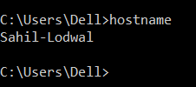

  - systeminfo :
- Shows detailed system info including network configs.
- Includes:
  - OS version
  - Hotfixes
  - Network card configuration

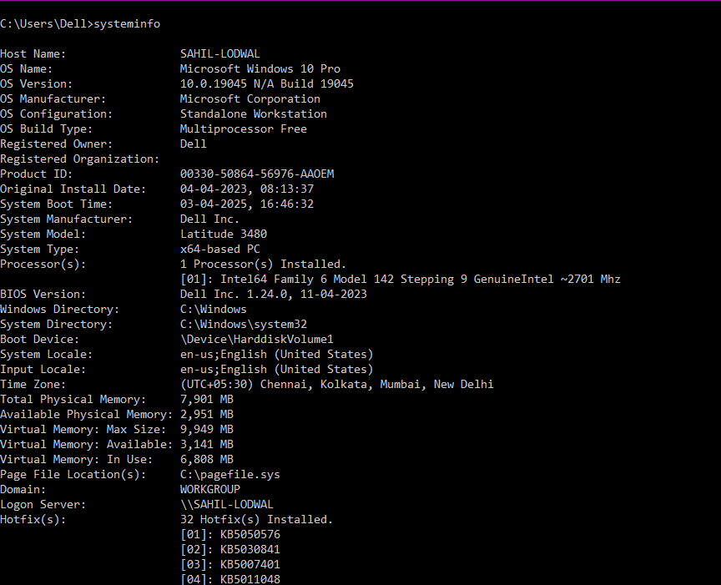
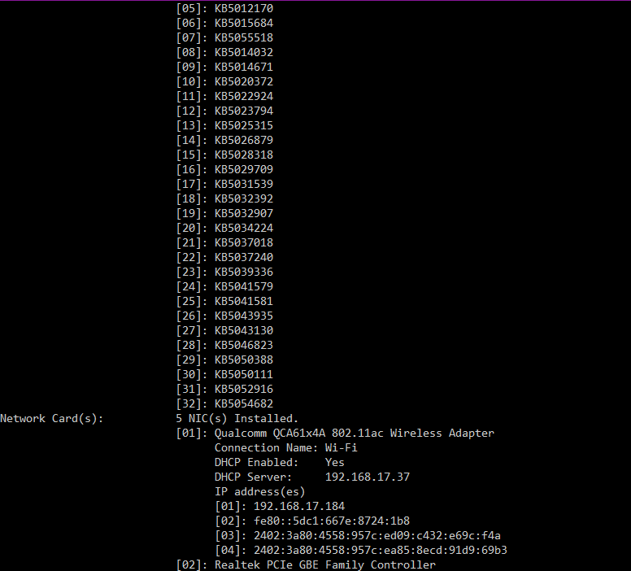

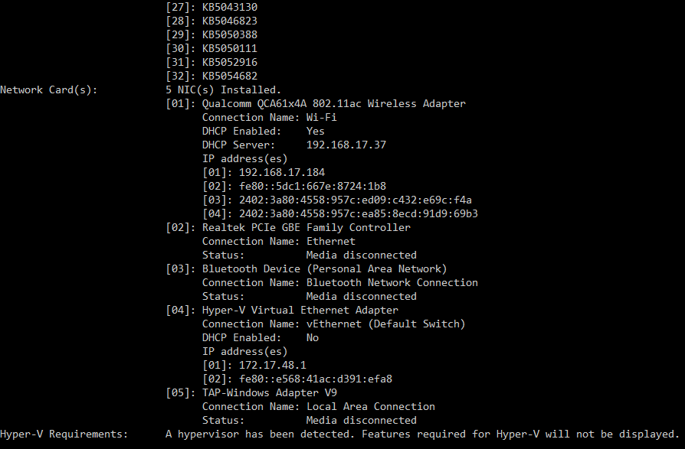

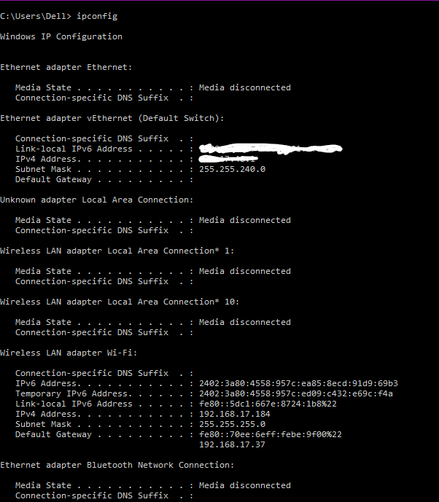
  - Ipconfig (IP Configuration) : Displays and manages IP configuration of your system.

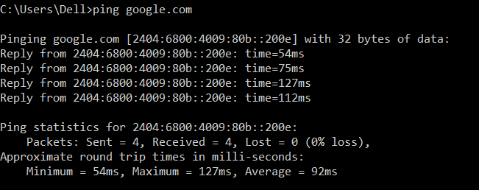
  - Ping : Tests connectivity with another device or server.

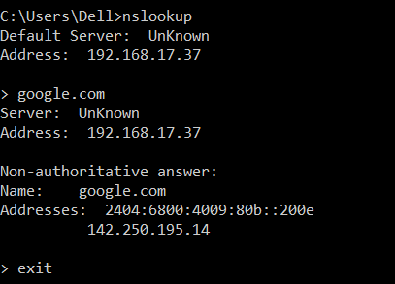
  - nslookup : used to query DNS servers to find the IP address of a domain or the domain name of an IP.

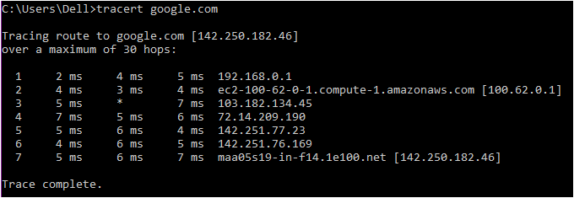
  - tracert : shows the path (hops) packets take to reach a destination and measures delay at each hop

